# Taxi Fare Prediction - Mini Project
import pandas as pd
import numpy as np
import matplotlib.pyplot as plt
from sklearn.model_selection import train_test_split
from sklearn.linear_model import LinearRegression
from sklearn.metrics import mean_absolute_error, mean_squared_error, r2_score

print("Taxi Fare Prediction - Mini Project")
print("All libraries imported successfully!")

Taxi Fare Prediction - Mini Project
All libraries imported successfully!

df = pd.read_csv("taxi_fare_500(1).csv")

print(df.shape)
(500, 8)

print(df.isnull().sum())
Trip_ID 0
Distance_km 0
Duration_min 0
Passengers 0
Traffic_Level 0
Peak_Hour 0
Weather 0
Fare 0
dtype: int64

print(df.describe())
Trip_ID Distance_km Duration_min Passengers Fare
count 500.00 500.000 500.000 500.000 500.000
mean 250.50 14.990 65.142 ... 502.891
std 144.48 8.499 37.351 ... 231.907
min 1.00 1.000 5.000 ... 105.490
25% 125.75 7.793 33.550 ... 296.185
50% 250.50 14.875 63.350 ... 499.240
75% 375.25 22.485 91.175 ... 691.230
max 500.00 29.930 150.000 ... 977.050

# Correlation
print(df[["Distance_km","Duration_min","Passengers","Fare"]].corr())

Distance_km Duration_min Passengers Fare
Distance_km 1.000000 0.913848 -0.032386 0.982409
Duration_min 0.913848 1.000000 -0.018270 0.956358
Passengers -0.032386 -0.018270 1.000000 0.005596
Fare 0.982409 0.956358 0.005596 1.000000

# EDA
#Histogram
plt.hist(df["Fare"], bins=25)
plt.xlabel("Fare")
plt.ylabel("Number of Trips")
plt.title("Distribution of Taxi Fare")
plt.show()

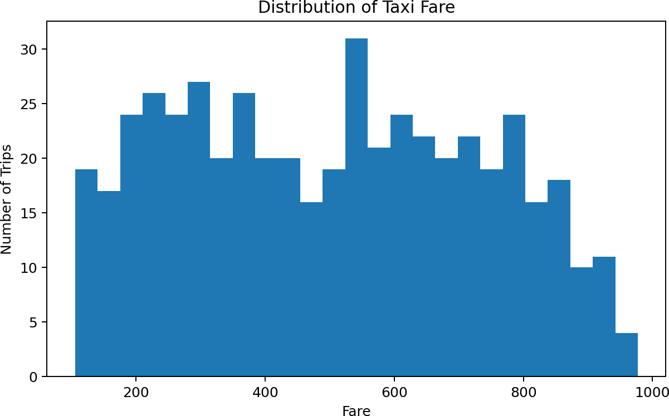

#Scatter
plt.scatter(df["Distance_km"], df["Fare"])
plt.xlabel("Distance (km)")
plt.ylabel("Fare")
plt.title("Distance vs Taxi Fare")
plt.show()

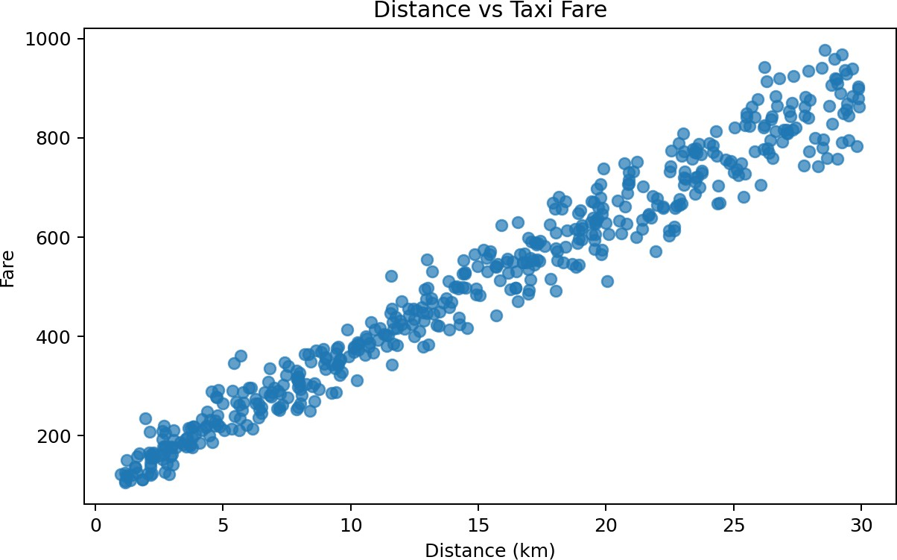
Distance has a strong positive relationship with fare in this dataset, with a Pearson correlation of 0.982. Longer trips generally have higher fares.

#Box plot
plt.boxplot(df["Fare"])
plt.title("Box Plot of Taxi Fare")
plt.ylabel("Fare")
plt.show()
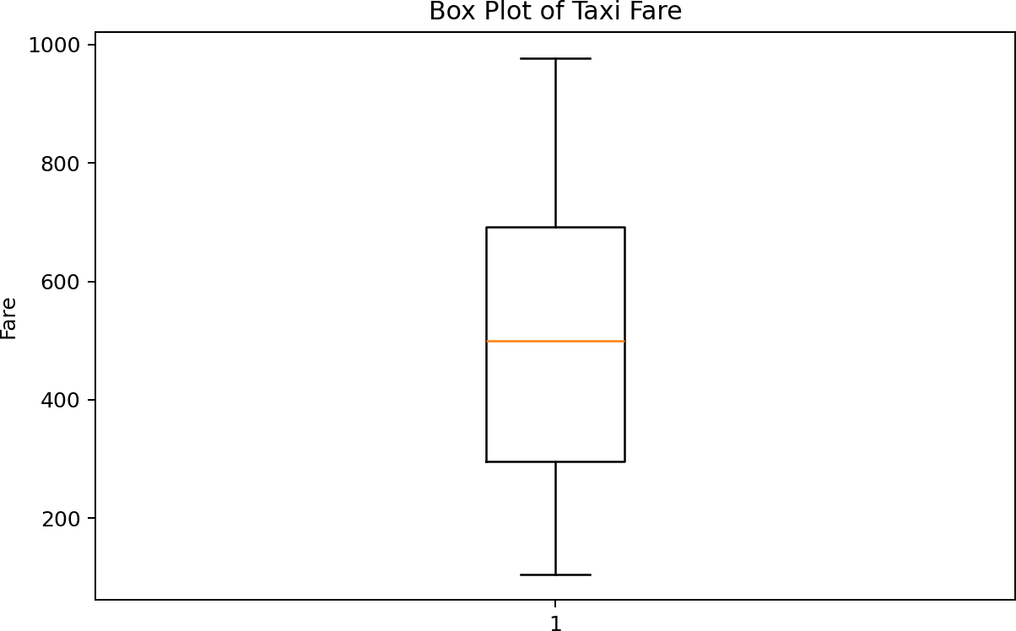
The histogram shows how taxi fares are distributed across the 500 trips. The box plot provides a compact view of the median, spread, and possible extreme observations.

# Average Fare by Traffic Level
average_fare = df.groupby("Traffic_Level")["Fare"].mean()
average_fare.plot(kind="bar")
plt.title("Average Fare by Traffic Level")
plt.xlabel("Traffic Level")
plt.ylabel("Average Fare")
plt.show()
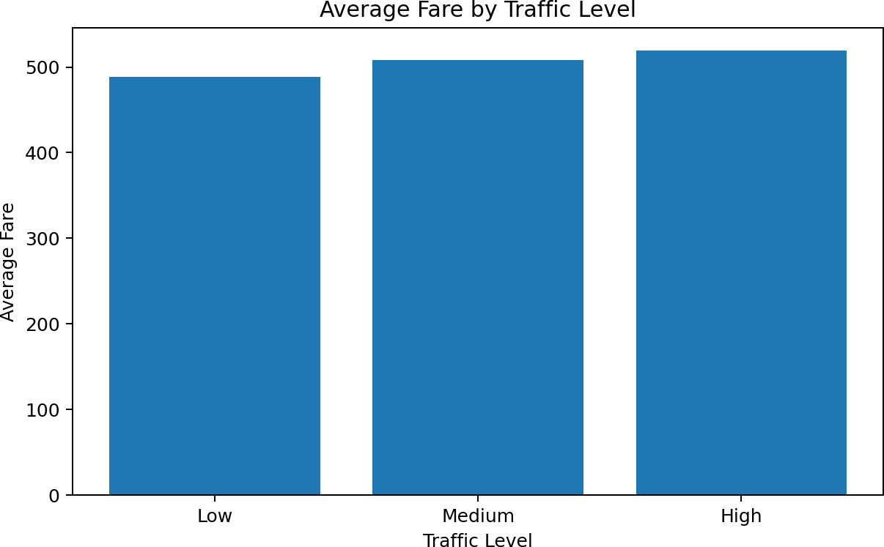
Average fare was compared across Low, Medium, and High traffic categories. This provides a simple view of how traffic category is associated with the fare in the provided dataset.
# Average Fare: Peak vs Non-Peak
average_fare = df.groupby("Peak_Hour")["Fare"].mean()
average_fare.plot(kind="bar")
plt.title("Average Fare: Peak vs Non-Peak")
plt.xlabel("Peak Hour")
plt.ylabel("Average Fare")
plt.show()
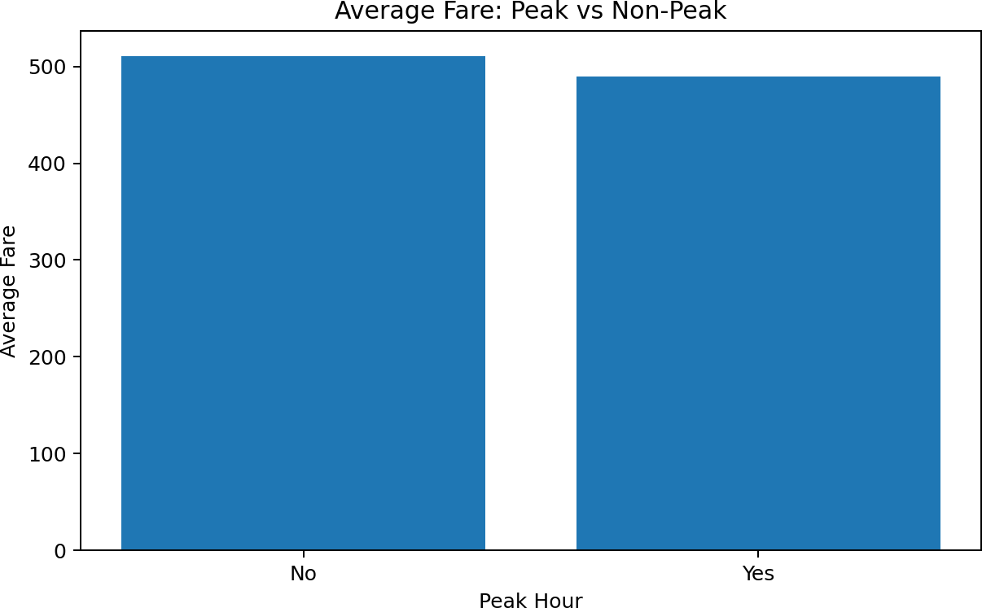
Average fare was compared between peak-hour and non-peak-hour trips.

#Correlation Matrix
import matplotlib.pyplot as plt
import numpy as np

corr = df.corr()

fig, ax = plt.subplots(figsize=(7, 6))
im = ax.imshow(corr, cmap='viridis', vmin=0, vmax=1)

ax.set_xticks(np.arange(len(corr.columns)))
ax.set_yticks(np.arange(len(corr.columns)))
ax.set_xticklabels(corr.columns, rotation=45, ha='right')
ax.set_yticklabels(corr.columns)

for i in range(len(corr.columns)):
for j in range(len(corr.columns)):
ax.text(j, i, f"{corr.iloc[i, j]:.2f}",
ha='center', va='center', color='black', fontsize=9)

ax.set_title('Correlation Matrix')
cbar = fig.colorbar(im, ax=ax)
cbar.set_label('Correlation')

plt.tight_layout()
plt.show()
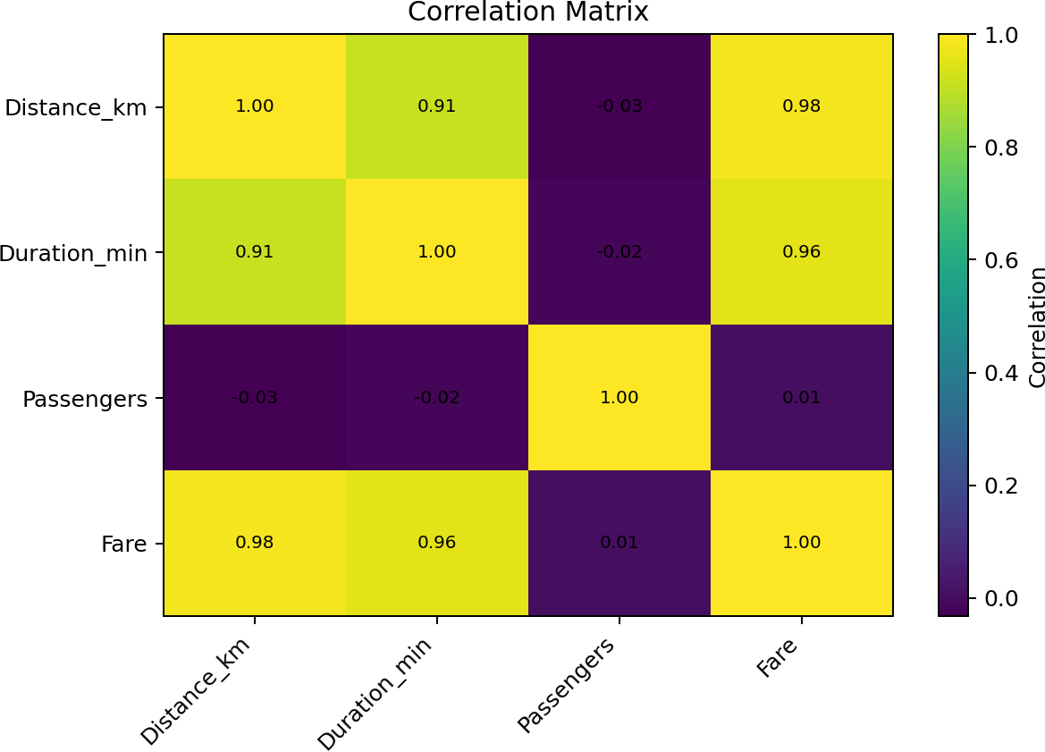
Pearson correlation was used to examine relationships between numerical variables. Distance and Duration show the strongest positive relationships with Fare, while Passenger count has a very small correlation with Fare.

# Regression model
X = df[["Distance_km", "Duration_min", "Passengers"]]
y = df["Fare"]

print("Input variables:", X.columns.tolist())
print("Target variable: Fare")

Input variables: ['Distance_km', 'Duration_min', 'Passengers']
Target variable: Fare

X_train, X_test, y_train, y_test = train_test_split(
X, y, test_size=0.20, random_state=42
)

print("Training data:", X_train.shape)
print("Testing data:", X_test.shape)

Training data: (400, 3)
Testing data: (100, 3)

model = LinearRegression()

model.fit(X_train, y_train)

y_pred = model.predict(X_test)

print("Linear Regression model trained successfully!")

Linear Regression model trained successfully!

mae = mean_absolute_error(y_test, y_pred)
mse = mean_squared_error(y_test, y_pred)
rmse = np.sqrt(mse)
r2 = r2_score(y_test, y_pred)

print("MAE:", mae)
print("MSE:", mse)
print("RMSE:", rmse)
print("R2 Score:", r2)

MAE: 20.45886393032158
MSE: 638.1110775728982
RMSE: 25.260860586545704
R2 Score: 0.9895278763790538

